|  |  |
| --- | --- |
|  | |
| National Park Service  U.S. Department of the Interior  Natural Resource Stewardship and Science | National Park Service Logo |

Visitor impact on the spatio-temporal distribution of coastal brown bears in Katmai National Park, Alaska

Natural Resource Report NPS/KATM/NRR—2017/XXX

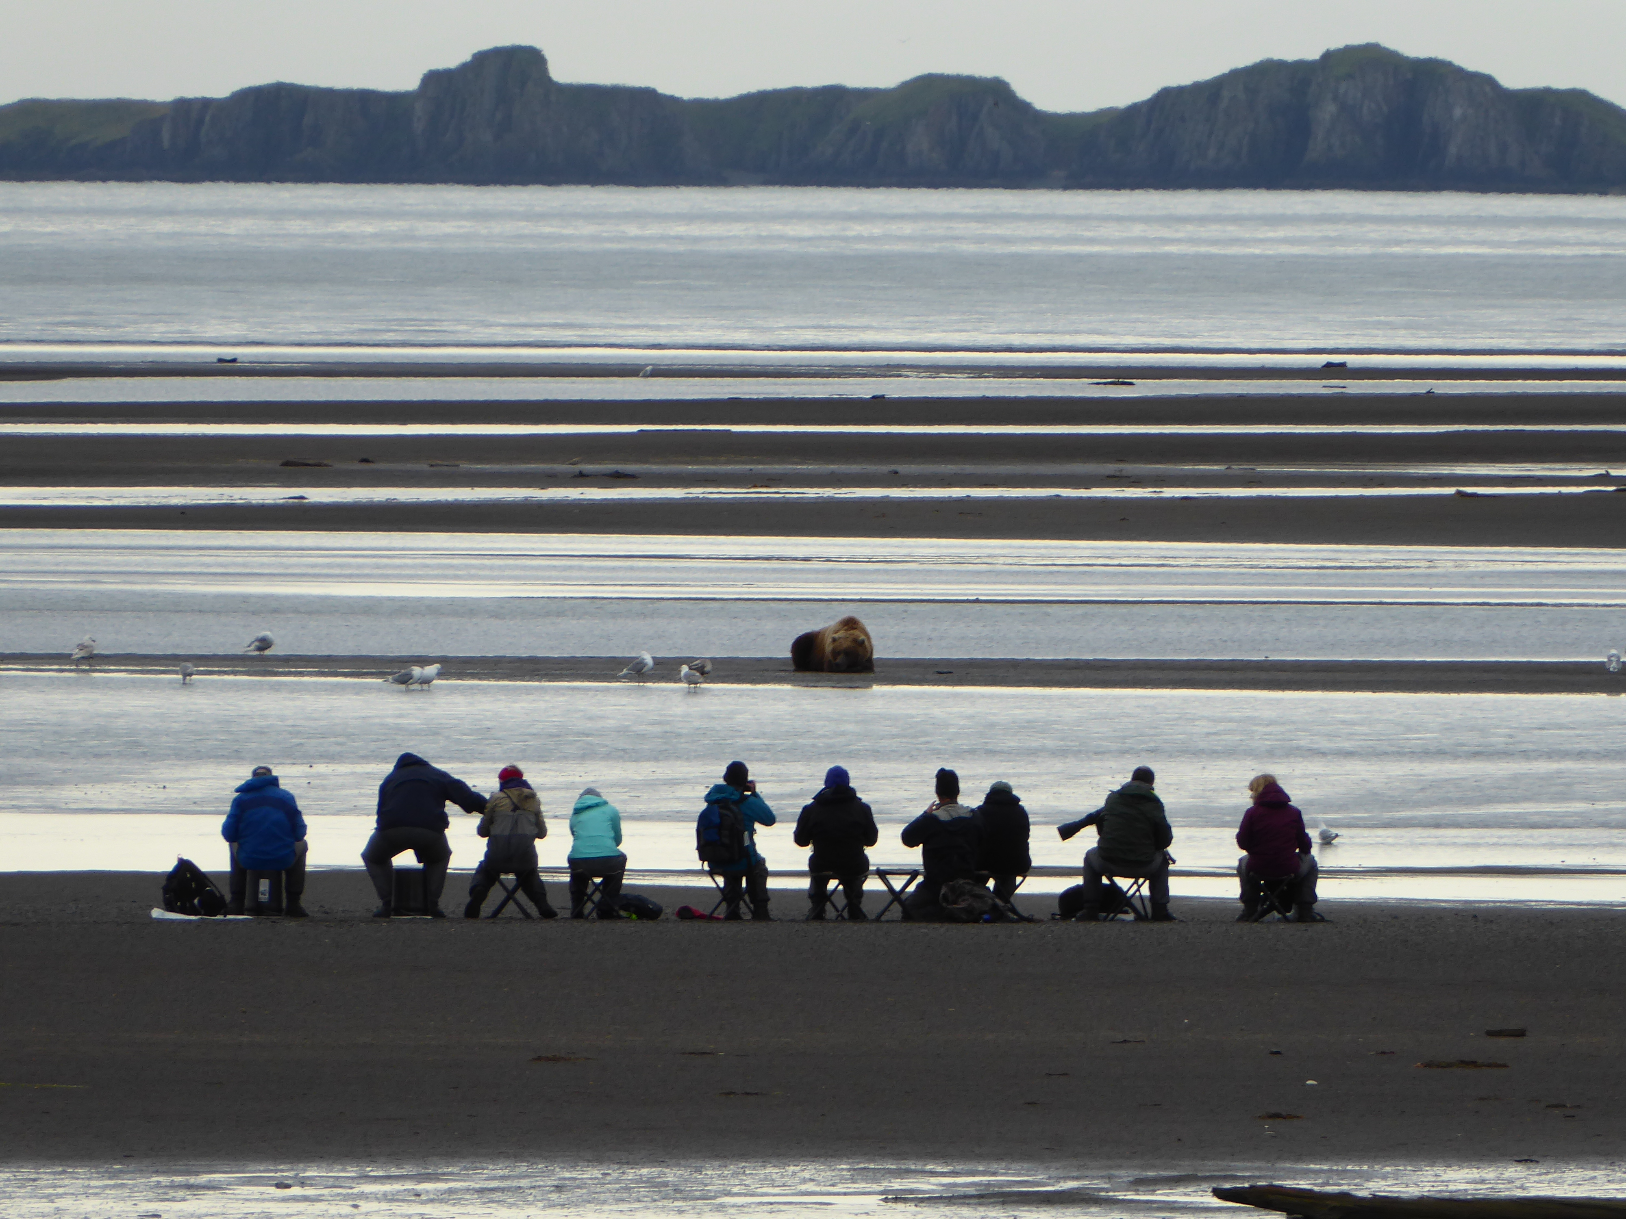

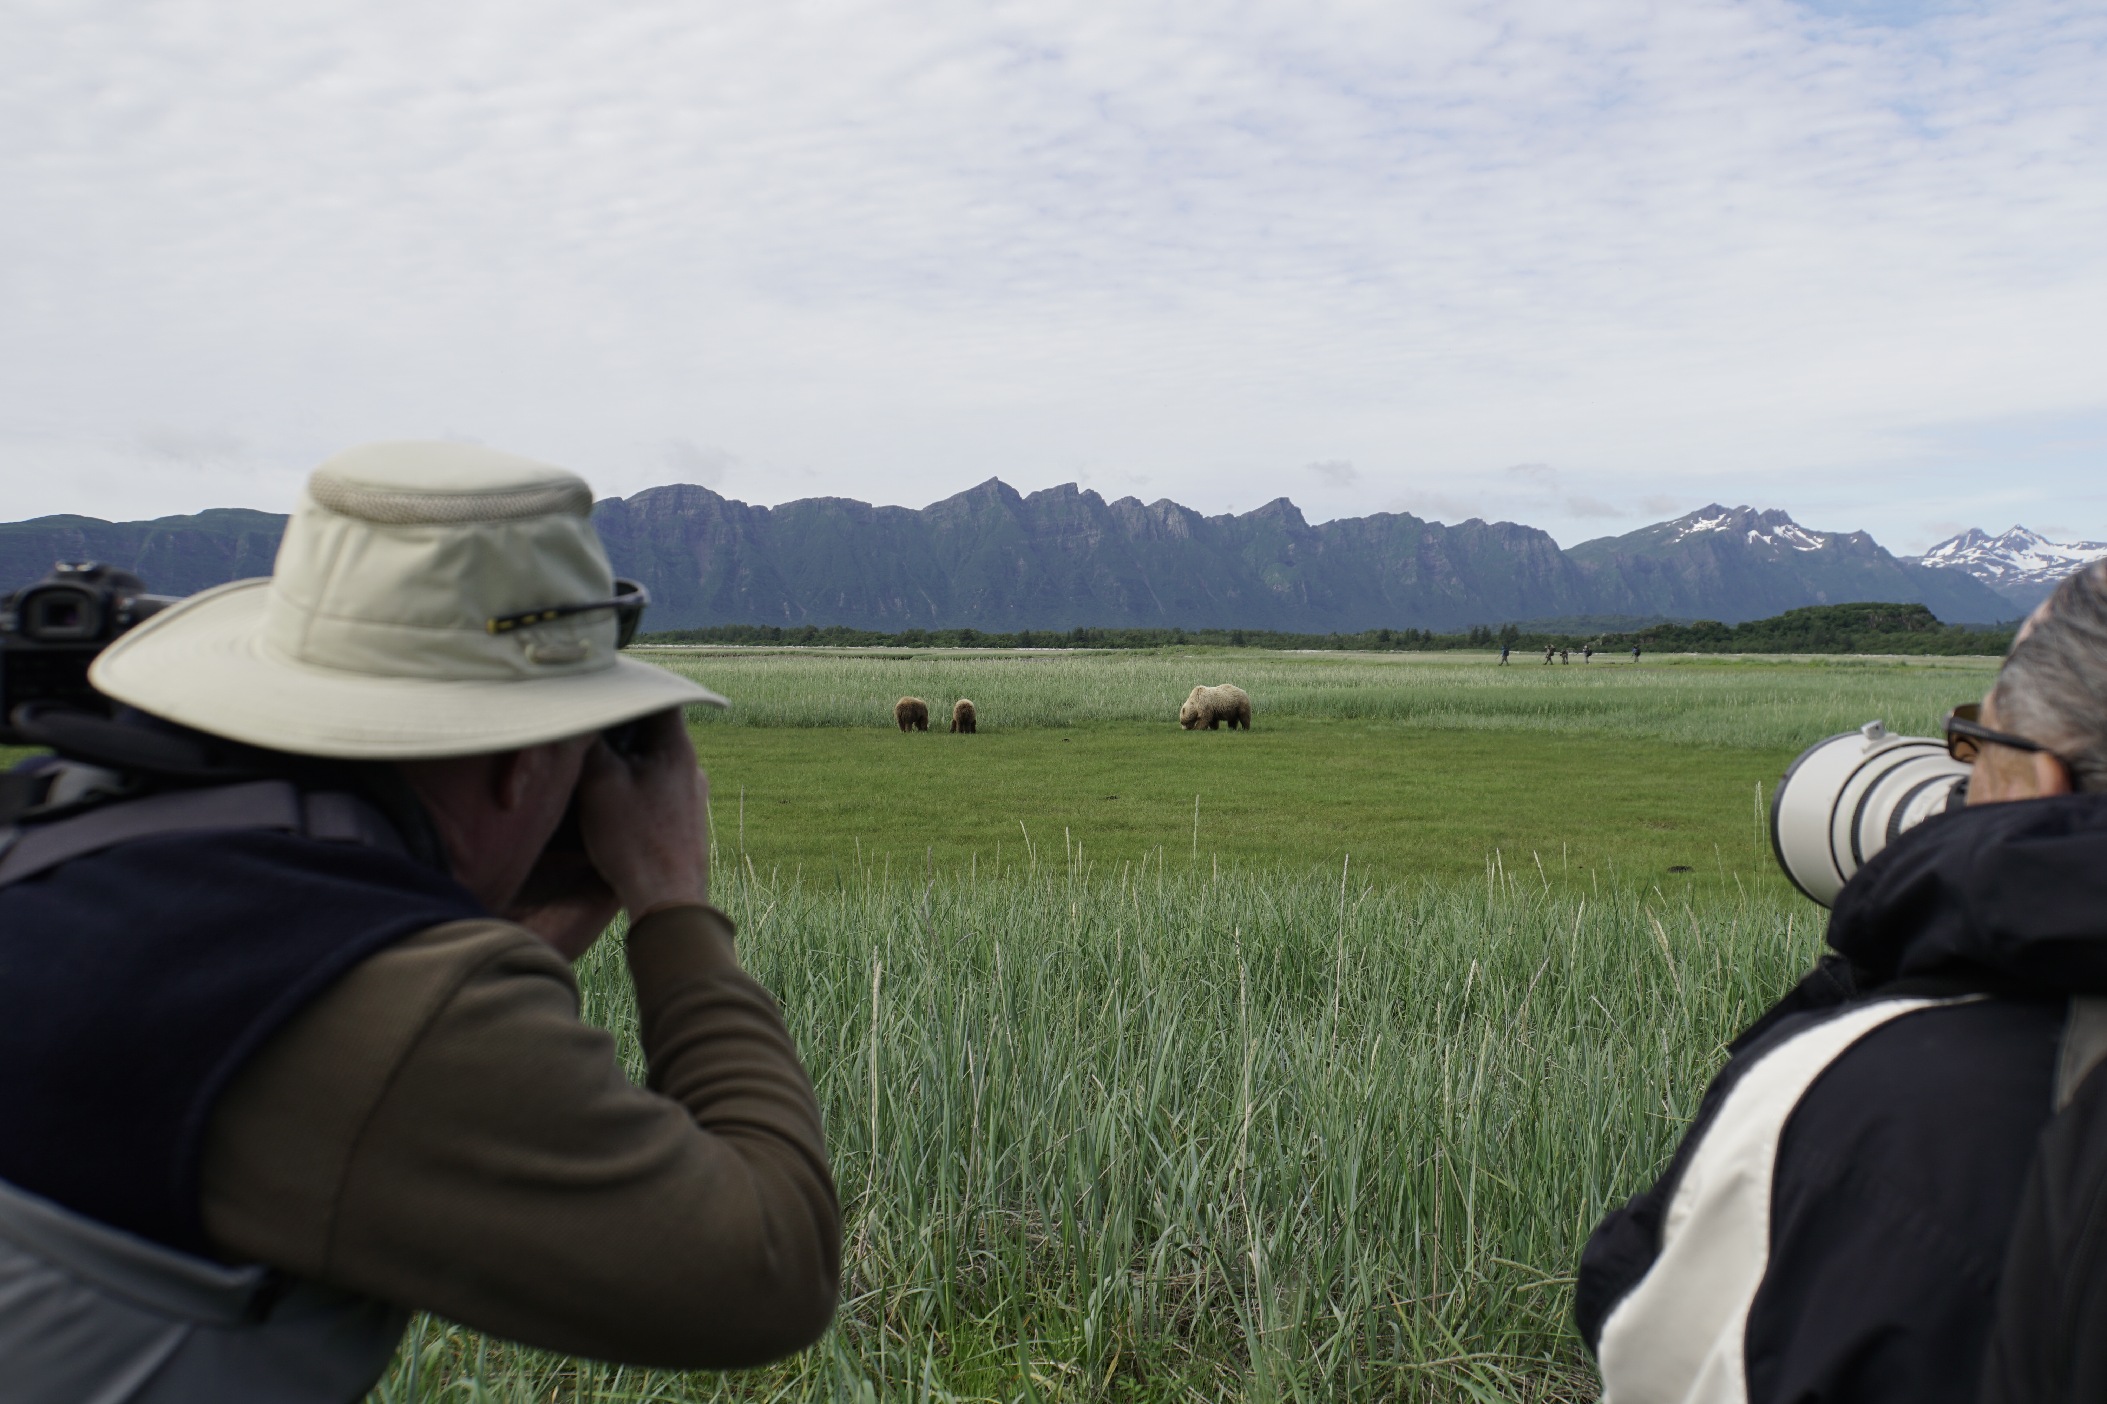

**ON THIS PAGE**

Photograph of visitors observing bears in a meadow at Hallo Bay, Katmai National Park. Note second visitor group towards the back of the meadow.

Photograph courtesy of K. Kunce, National Park Service

**ON THE COVER**

Photograph of a visitor group observing a bear at Hallo Bay, Katmai National Park.

Photograph courtesy of K. Griffin, National Park Service

Visitor impact on the spatio-temporal distribution of coastal brown bears in Katmai National Park, Alaska

Natural Resource Report NPS/KATM/NRR—2017/XXX

Kelsey R. Griffin

National Park Service  
Katmai National Park  
P.O. Box 7  
King Salmon, Alaska 99613

Month 2017

U.S. Department of the Interior  
National Park Service  
Natural Resource Stewardship and Science

Fort Collins, Colorado

The National Park Service, Natural Resource Stewardship and Science office in Fort Collins, Colorado, publishes a range of reports that address natural resource topics.These reports are of interest and applicability to a broad audience in the National Park Service and others in natural resource management, including scientists, conservation and environmental constituencies, and the public.

The Natural Resource Report Series is used to disseminate comprehensive information and analysis about natural resources and related topics concerning lands managed by the National Park Service. The series supports the advancement of science, informed decision-making, and the achievement of the National Park Service mission. The series also provides a forum for presenting more lengthy results that may not be accepted by publications with page limitations.

All manuscripts in the series receive the appropriate level of peer review to ensure that the information is scientifically credible, technically accurate, appropriately written for the intended audience, and designed and published in a professional manner.

**You must add a peer review statement here that has been approved by the Peer Review Manger of the report (**Rules/Guidance & Examples You Can Use**).**

Views, statements, findings, conclusions, recommendations, and data in this report do not necessarily reflect views and policies of the National Park Service, U.S. Department of the Interior. Mention of trade names or commercial products does not constitute endorsement or recommendation for use by the U.S. Government.

This report is available in digital format from Your_Office_Namewebsite (http://...), and the Natural Resource Publications Management website [(http://www.nature.nps.gov/publications/nrpm/](http://www.nature.nps.gov/publications/nrpm/)). To receive this report in a format optimized for screen readers, please email [irma@nps.gov](mailto:irma@nps.gov?subject=irma@nps.gov)**.**

Please cite this publication as:

Lastname, A. B., C. Lastname, and D. E. Lastname. 20XX. Full title of report in sentence case: Including subtitle. Natural Resource Report NPS/XXXX/NRR—2014/XXX. National Park Service, Fort Collins, Colorado. (Rules/Guidance)

NPS XXXXXX, Month 201X (The Fort Collins Support Office will fill out this line for you)

Contents

Page

Figures iv

Tables v

Appendices v

Abstract vi

Acknowledgments vi

Introduction 1

Methods 3

Analysis 5

Results 6

Katmai Bay: site with no visitation 6

Bear numbers 6

Swikshak Lagoon: site with some visitation 7

Bear numbers 7

Visitor numbers 8

Bear patterns and visitation effects 10

Spatial distribution of bears and visitors 10

Discussion 11

Conclusions 13

Literature Cited 14

Appendix A: Best practices for viewing bears on the west side of cook inlet and the Katmai Coast

A-1

Figures

Page

**Figure 1**. Coastal time-lapse photography study sites in Katmai National Park and Preserve. Studies were conducted 2007-2009 at Geographic Harbor, 2010-11, 2013-14 at Katmai Bay, and 2012-2014 at Swikshak Lagoon. Park Headquarters are located in King Salmon. 2

**Figure 2.** Photos indicating low, medium, and high tide categorization at a) Swikshak lagoon (note level of sandbar exposure and exposure along bank edges, and b) Katmai Bay (note Fig. 4 displays more detailed photo and explanation of how tide categorization was determined). 4

**Figure 3**. a) Photo taken from the Katmai Bay time-lapse cameras, box represents area used to evaluate tide level. b) Photo zoomed in to show features within the tidal area used to determine low, medium and high tide stage for analysis. 5

**Figure 4**. Number of bears observed in each photo from a time-lapse photography study at Katmai Bay (2010-11, 2013-14) in relation to variables **a)** day of year and **b)** time of day across all years. Mean number of bears observed in photos in relation to variables **c)** year and **d)** tide stage across all years. Continuous variables (day of year, time of day) have LOESS line of fit (red line). Time of day was corrected to represent 100 units per hour, and to include after midnight light periods as part of previous day. Error bars represent a 95% confidence interval. 6

**Figure 5.** Number of bears observed in each photo from a time-lapse photography study at Swikshak Lagoon (2010-11, 2013-14) in relation to variables **a)** day of year and **b)** time of day across all years. Mean number of bears observed in photos in relation to variables **c)** year and **d)** tide stage across all years. Continuous variables (day of year, time of day) have LOESS line of fit (red line). Time of day was corrected to represent 100 units per hour, and to include after midnight light periods as part of previous day. Error bars represent a 95% confidence interval. 8

**Figure 6.** Number of visitors observed in each photo from a time-lapse photography study at Swikshak Lagoon (2012-2014) in relation to variables **a)** day of year, **b)** time of day, **c)** year, and **d)** tide stage across all years of data collection. Continuous variables (day of year, time of day) have LOESS line of fit (red line). Time of day was corrected to represent 100 units per hour, and to include after midnight light periods as part of previous day. 9

**Figure 7.** Mean number of visitors observed in photos from a time-lapse photography study at Swikshak Lagoon (2012-2014) in relation to variables **a)** year and **b)** tide stage. Error bars represent a 95% confidence interval. 9

**Figure 8.** Bear and person (visitor) spatial distribution at Swikshak lagoon when visitors were present in (south side of lagoon). Contour lines represent density of bears and people that were georeferenced as points. 11

**Figure 9.** Number of bears observed in each photo from a time-lapse photography study at Geographic Harbor (2007-2009) in relation to variables a) day of year and b) time of day across all years. Mean number of bears observed in photos in relation to variables c) year and d) tide stage across all years. Continuous variables (day of year, time of day) have LOESS line of fit (red line). Time of day was corrected to represent 100 units per hour, and to include after midnight light periods as part of previous day. Error bars represent a 95% confidence interval. Original data analysis (Turner 2012). 12

Tables

Page

**Table 1.** Katmai National Park time-lapse photography sites and photo collection seasons. Number of photos scored includes all photos that were used in analysis. 3

**Table 2.** ANCOVA model at Katmai Bay to compare bear presence and association of variables of day of year (3rd order transformation), time of day (2nd order transformation), year, and tide stage. 7

**Table 3.** ANCOVA model at south side of Swikshak Lagoon (bears and visitors present) to compare bear presence and association of variables of day of year (3rd order transformation), time of day (2nd order transformation), year, and tide stage. 10

**Table 4.** ANCOVA model at north side of Swikshak Lagoon (bears and no visitor presence) to compare bear presence and association of variables of day of year (3rd order transformation), time of day (2nd order transformation), year, and tide stage. 10

Appendices

Page

Appendix A: Best practices for viewing bears on the west side of cook inlet and the Katmai Coast

A-1

Abstract

Visitor activity along coastal sites of Katmai National Park has risen over the past two decades primarily due to increases in brown bear (*Ursus arctos*) viewing. A series of time-lapse photography studies have been implemented at three coastal bear viewing sites to determine how varying levels of visitor activity may affect bear activity and spatial distribution. We set up cameras at each site and photos were taken at set intervals for the duration of the bear-viewing season across multiple years. All bears and visitors present within the photos were digitized and relative positions were used to determine density patterns and relationships. We analyzed bear activity patterns in relationship to temporal variables and bear spatial distribution in the presence and absence of visitors. Bear activity varied between sites and with year, day of year, time, and tide. Visitor presence alone did not seem to affect bear activity and spatial distribution. However, multiple visitor groups and high visitor numbers appeared to displace bears and change their activity patterns. Management strategies at Katmai include continued monitoring of visitor numbers and density at bear viewing sites to determine levels of visitation. High-visitation sites should be management priorities and may benefit from increased ranger presence or designated viewing areas to minimize the impact on bears.

Acknowledgments

This study was funded by the U.S. National Park Service. Thanks to all NPS permanent and seasonal employees who participated in project logistics, data collection, data entry, and QA/QC. Thanks to C. Turner for providing her previous study results and edits. Thanks to T. Wilson and T. Hamon for help through the data analysis and editing process.

Introduction

Katmai National Park (Katmai), located on the Alaska Peninsula, has several coastal sites that have become increasingly popular among visitors for bear viewing and photography. Bear viewing is the primary reason for many people to visit Katmai (Strawn and Le 2014). The Katmai coast is rich with natural food resources that support a high density of coastal brown bears (*Ursus arctos)* (Miller et al. 1997, Sellers et al. 1999). Coastal sites provide ample bear viewing opportunities during the summer season and are accessible only by boat or plane. Due to limited access, visitors primarily book guided visits through businesses with commercial use authorizations (CUAs). CUAs provide visitors with guiding, transportation, and outfitting services to coastal sites within Katmai. Coastal sites are managed through ranger patrols and guidelines set forth by the Best Bear Viewing Practices (BBVP) (Appendix A), Code of Federal Regulations, CUA stipulations, and Superintendent’s Compendium. Seasonal backcountry ranger patrols are limited due to site remoteness and financial constraints; therefore, Katmai relies primarily on CUA and visitor compliance with the BBVP. The National Park Service developed the BBVP in 2003 in conjunction with the Alaska Department of Fish and Game, input from CUAs who work along the Katmai Coast, and the general public. The goal of the BBVP is to provide best practice guidelines that minimize disturbance to bears and their habitat while providing visitors with the opportunity to observe and learn about bears (Appendix A).

An understanding of bear and human use along the coast and visitation impacts on bear activity is essential to evaluate the effectiveness of current management practices and determine future management needs. One of the most common impacts of human visitation (bear viewers and anglers) on bears is *spatial and temporal displacement* (Fortin et al. 2016). Bear displacement from prime foraging habitats can result in negative consequences for bears including reduced foraging time and increased stress and energetic costs (Smith and Partridge 2004). Katmai began time-lapse photography studies starting in 2004 to document bear and visitor spatial and temporal distribution. Time-lapse photography serves as a cost-effective method to collect data throughout the season during daylight hours without the need for an on-site observer. The study began with bear use at the Brooks River (Hamon et al. 2007) and has expanded to include coastal sites (Fig. 1). The first coastal study was conducted from 2007-09 at Geographic Harbor (Turner 2012). Geographic Harbor is a popular bear viewing site where bears can be found foraging in sedge meadows, digging for clams in the intertidal zone, and fishing during the salmon run. Bear spatial distribution and activity changed with increased visitor use (Turner 2012). Bear numbers decreased with an increase in visitor numbers and bears occupied fewer locations when visitors were present. Bear numbers were higher when rangers were present, which is also when visitors were more spatially concentrated, suggesting ranger presence affected visitor behavior and distribution. As a result of the Geographic Harbor study, Katmai began stationing rangers at Geographic Harbor and Hallo Bay in 2014, both coastal sites with high visitor and bear numbers.

Time-lapse photography studies at two additional Katmai Coast locations (Fig. 1) were completed to determine how bears utilize sites in areas with varying levels of visitation. Both sites consisted of tidally influenced salt marsh where bears forage primarily on sedge. Salt marsh and intertidal zones provide important foraging opportunities for bears in spring and summer before salmon and berries are available (Smith and Partridge 2004). The studies were conducted from 2012-2014 at Swikshak Lagoon (some visitor presence) and 2010-11 and 2013-14 at Katmai Bay (no visitor presence). Both studies followed the time-lapse photography protocol from previous Katmai studies (Nicolato and Turner 2014). The goals of this study are to 1) determine bear and visitor use patterns in relation to temporal and spatial variables at Swikshak Lagoon and Katmai Bay, 2) investigate the effects of visitor presence on bear numbers and spatial distribution, 3) compare bear temporal and spatial distribution at sites with no visitation (Katmai Bay), some visitation (Swikshak), and high visitation (previous study at Geographic Harbor), and 4) use the results of this study to inform the development of Katmai’s backcountry management plan.

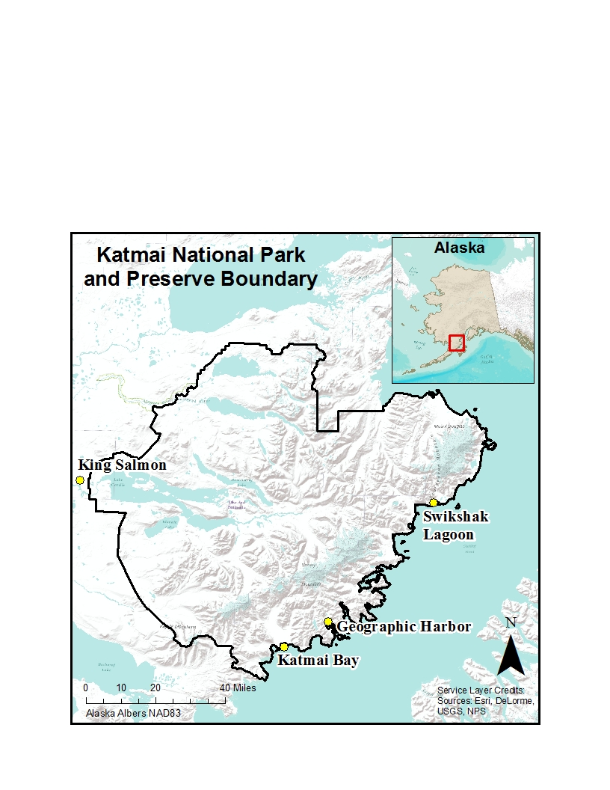

**Figure 1**. Coastal time-lapse photography study sites in Katmai National Park and Preserve. Studies were conducted 2007-2009 at Geographic Harbor, 2010-11, 2013-14 at Katmai Bay, and 2012-2014 at Swikshak Lagoon. Park Headquarters are located in King Salmon.

Methods

We set up two cameras at each site overlooking Swikshak Lagoon and Katmai Bay. Cameras were fitted with wide-angle lenses and connected to time-lapse controllers (Digisnap 2800, Harbortronics Inc.). Cameras and time-lapse controllers were powered by 12 V batteries charged using 10 W solar panels. Cameras were camouflaged and installation included electric fences with charge capacities of 9700 V to prevent animal disturbances. Photos were taken at regular intervals (every 30 minutes) throughout each season (Table 1). Despite fence installation, some disturbance still occurred, resulting in camera failure and periods without photos. Sites were visited periodically throughout each season to ensure the installations were still functioning and to perform camera card changes. When camera failures occurred, photos from two cameras were used to fill in data gaps when possible. Photos that were too blurry (due to weather) or dark to identify objects were marked as unscored.

**Table 1.** Katmai National Park time-lapse photography sites and photo collection seasons. Number of photos scored includes all photos that were used in analysis.

|  |  |  |  |  |  |  |  |  |
| --- | --- | --- | --- | --- | --- | --- | --- | --- |
|  | **Swikshak Lagoon** | | | | **Katmai Bay** | | | |
|  | 2012 | 2013 | 2014 | 2010 | | 2011 | 2013 | 2014 |
| photo collection dates | 6/2-10/9 | 4/28-9/22 | 4/28-9/23 | 6/4-9/12 | | 6/5-9/26 | 5/29-8/5 | 5/23-9/2 |
| photo gap dates | none | 5/13-6/21 | 5/12-6/13 | none | | none | 6/20-7/10 | none |
| # photos scored | 1889 | 1490 | 1325 | 2061 | | 2308 | 2923 | 1498 |

We digitized all scored photos (used in analysis) in ArcMap (10.3.1, Environmental Systems Research Institute, Redlands, CA) using common reference points in the landscape from a base photo to establish a coordinate grid and ensure locational accuracy. We marked objects of interest (bears and people) in each photo as points to obtain x and y coordinates for each object. We were unable to determine consistently sex or age class of bears from photos. Bears were marked and counted individually even if they may have been in a family group. People marked in high density groups were difficult to distinguish from one another; therefore, data indicates a minimum number of people. After processing photos for each location and year, quality control was performed to check for inaccuracies, errors, and missing data. Camera shifts occurred at both sites resulting in a shift in photo frame extent. Photo objects that were marked outside of the base photo frame extent were not used in analyses. The photo frame extent at Swikshak Lagoon was limited by the camera angle and frame on both the North and South sides and may not have included all bears and people actually present. Other variables used in analyses included year, time of day, day of year, tide, visitor presence, and ranger presence.

Time of day was converted to a continuous variable with hour as 1-25 and minutes corrected to represent 100 units per hour. After midnight light until 1 a.m. was recorded as minutes from 2400 to 2500. Dates were converted to day of year (number within 365-366 days of the year). Tide stage at Swikshak Lagoon and Katmai Bay was determined in each photo through visual categorization of low, medium, and high (Fig 2). Tides at Swikshak Lagoon were categorized based on level of sandbar and bank edge exposure. The tide at Katmai Bay was considered high if, at a minimum, water surrounded a specific grassy knoll adjacent to the main sedge meadow (Fig 3a.). Tide was categorized as medium if the prominent sand bar indicated in the zoomed in photo (Fig 3b.) was at least partially covered with water. All other photos with lower water levels were categorized as low. Visitor presence was categorized based on the presence or absence of visitors in each photo.

**a)** 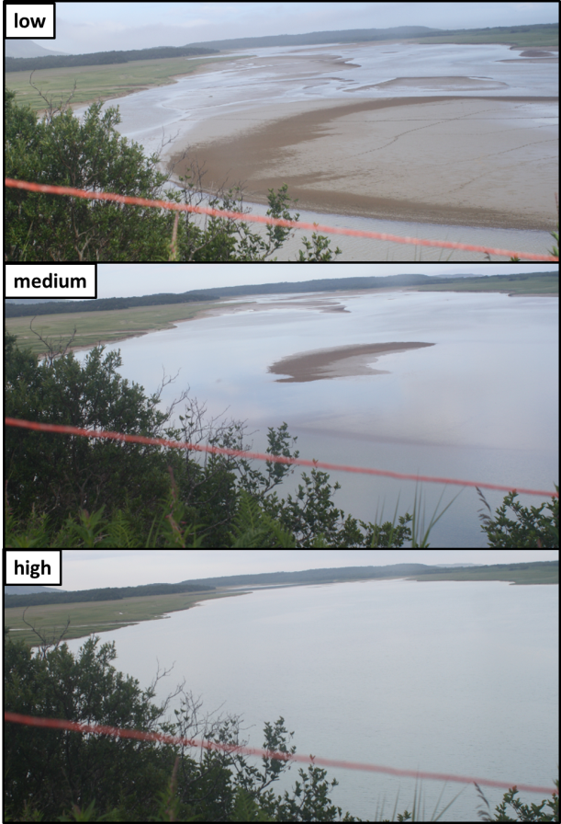 **b)**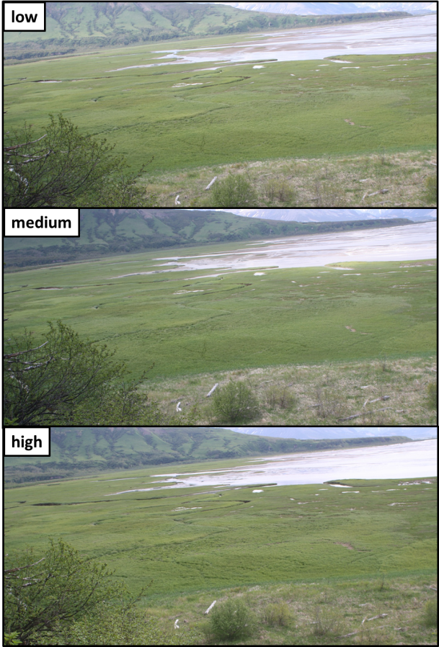

**Figure 2.** Photos indicating low, medium, and high tide categorization at a) Swikshak Lagoon (note level of sandbar exposure and exposure along bank edges, and b) Katmai Bay (note Fig. 3 displays more detailed photo and explanation of how tide categorization was determined).

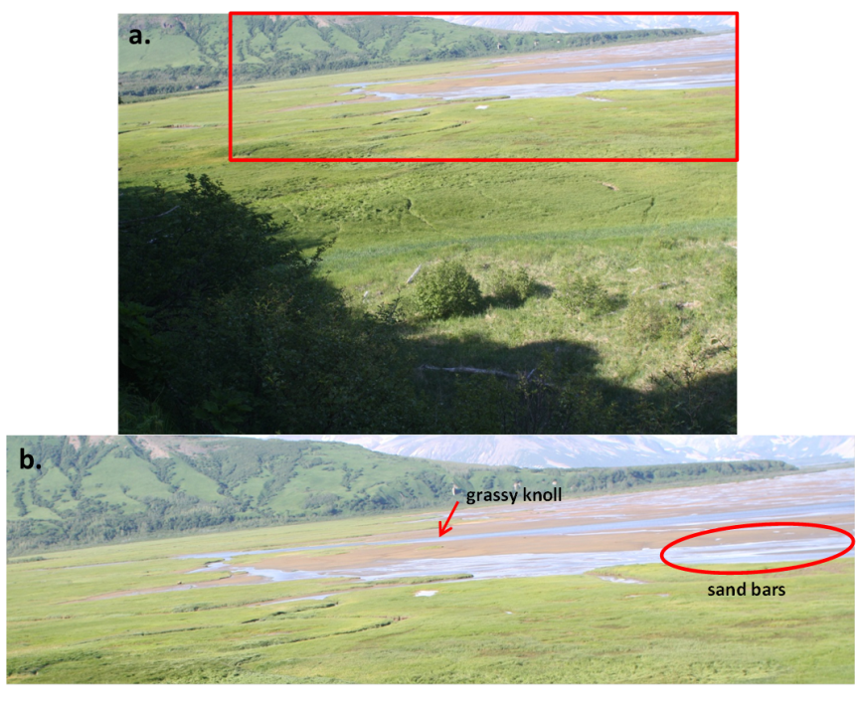

**a)**

**b)**

**Figure 3**. a) Photo taken from the Katmai Bay time-lapse cameras, box represents area used to evaluate tide level. b) Photo zoomed in to show features within the tidal area used to determine low, medium and high tide stage for analysis.

Analysis

We generated scatterplots using the statistical computing environment R (version 3.3.2, 2016) of bears and visitors with variables of time of day, day of year, tide, and year to determine general bear patterns and variable associations. Locally weighted scatterplot smoothing (LOESS) lines of fit were added to plots with continuous variables. We calculated mean numbers of bears and people for categorical variables of year and tide stage.

We constructed generalized linear models in R with bear numbers and predictive variables of day of year, time of day, tide, and year. We scaled day of year and time of day. Several analysis of covariance (ANCOVA) models were created using the AOV command and compared using the ANOVA command and Akaike Information Criterion (AIC). The best fit model included 2nd order (time of day) and 3rd order (day of year) polynomial transformations to fit the curves in the data. We calculated mean bear numbers from model residuals in relation to tide level, day of year, time of day, and year. We compared mean bear residuals during visitor presence and absence. We performed a one-way ANOVA to compare bear numbers in the presence and absence of visitors. Visitor levels were not categorized further due to low visitor totals. The number of times with both visitors and rangers present was too few to evaluate changes to visitor activity or impact as a result of ranger presence.

Photo object spatial data was analyzed in R through the creation of density plots displaying bear and visitor distribution on the landscape. We created a visitor zone (including area of all visitation) and a high density visitor zone in R to look at the effect of visitation on bear distribution. Density contours created from numbers of visitors served as the outline for the visitor zones that were georeferenced in ArcMap. Visitor zones represented as polygon shapefiles were used to extract bear points in and out of each zone. Chi-square analyses were used to compare observed and expected frequencies of bears in and out of the visitor zones during times of visitation and no visitation.

Results

Katmai Bay: site with no visitation

Bear numbers

Bear presence ranged from the first day photos were taken (day 143, May 23) to day 268 (September 25), one day prior to the last day photos were taken. There were 16,452 bear observations made within the photo frame extent in photos across all four seasons. Bears were present in 69% of all photos with a maximum of 11 bears present in a photo. Bear numbers increased early in the season, remained relatively constant during the season, and then gradually decreased (Fig 4a). Average bear presence across all years occurred around day 188 (July 7). Bears occurred across daylight hours typically beginning around 5 am through the midnight hour (Fig 4b). Bear numbers gradually increased as the day progressed with an average occurrence at 1560 (approximately 3:36 pm). Average bear numbers differed among years with the highest average in 2013 (2.8), followed by 2010 (2.0), 2011 (1.3), and 2014 (0.8), respectively (Fig 4c). Average bear numbers also differed among tide stages with higher averages at low (1.9) and medium (2.0) tide compared to high tide (1.7) (Fig 4d).

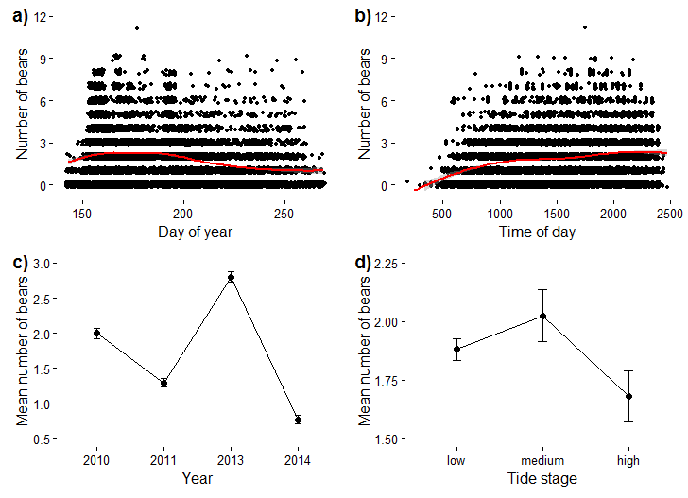

**Figure 4**. Number of bears observed in each photo from a time-lapse photography study at Katmai Bay (2010-11, 2013-14) in relation to variables **a)** day of year and **b)** time of day across all years. Mean number of bears observed in photos in relation to variables **c)** year and **d)** tide stage across all years. Continuous variables (day of year, time of day) have LOESS line of fit (red line). Time of day was corrected to represent 100 units per hour, and to include after midnight light periods as part of previous day. Error bars represent a 95% confidence interval.

We used ANCOVA analysis to determine the importance of variables of day of year, time of day, year, and tide stage in relation to bear presence. Bear presence at Katmai Bay was most strongly associated with year, followed by time of day, day of year, and tide stage (Table 2.).

**Table 2.** ANCOVA model at Katmai Bay to compare bear presence and association of variables of day of year (3rd order transformation), time of day (2nd order transformation), year, and tide stage.

|  |  |  |  |  |
| --- | --- | --- | --- | --- |
| Variable | Df | Sum Sq | F value | *P* |
| Year | 3 | 11466 | 1682.5 | < 0.0001 |
| Time of day | 1 | 504 | 221.8 | < 0.0001 |
| Time of day^2 | 1 | 213 | 93.7 | < 0.0001 |
| Day of year | 1 | 209 | 91.9 | < 0.0001 |
| Day of year^3 | 1 | 200 | 88.2 | < 0.0001 |
| Tide stage | 2 | 27 | 5.9 | 0.003 |

Swikshak Lagoon: site with some visitation

Bear numbers

Bear presence occurred as early as day 118 (April 28) and as late as day 275 (October 2) over the course of all seasons. There were 7,479 bear observations made within the photo frame extent in photos across all three seasons. Bears were present in 40% of all photos with a maximum of 17 bears present in a photo. Bear numbers fluctuated during the season across all years with an average occurrence and peak around day 189 (July 8) after which numbers began to decrease (Fig 5a). Bear presence occurred across daylight hours beginning around 5 am through the midnight hour (Fig 5b). Bear numbers gradually increased as the day progressed with an average occurrence at 1569 (approximately 3:40 pm). Average bear numbers differed among years with the highest average in 2012 (2.2), followed by 2013 (1.4), and 2014 (0.9), respectively (Fig 5c). Average bear numbers also differed among tide stages with the highest average at medium tide (1.9) and no difference in averages among low (1.5) and high tide (1.5) (Fig 5d).

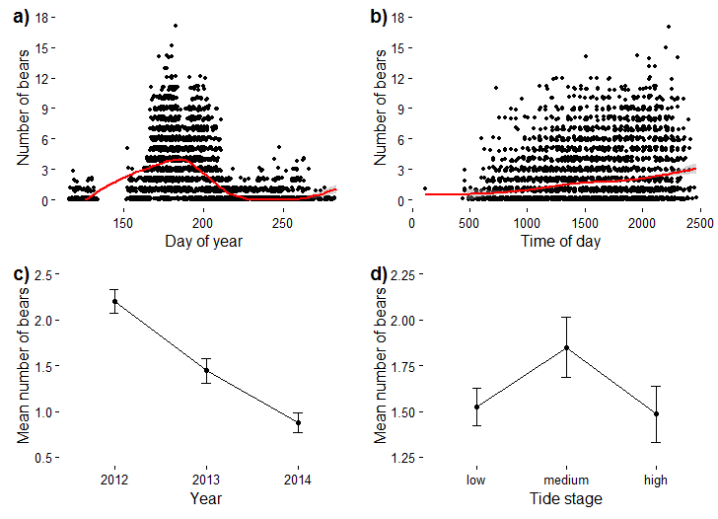

**Figure 5.** Number of bears observed in each photo from a time-lapse photography study at Swikshak Lagoon (2010-11, 2013-14) in relation to variables **a)** day of year and **b)** time of day across all years. Mean number of bears observed in photos in relation to variables **c)** year and **d)** tide stage across all years. Continuous variables (day of year, time of day) have LOESS line of fit (red line). Time of day was corrected to represent 100 units per hour, and to include after midnight light periods as part of previous day. Error bars represent a 95% confidence interval.

Visitor numbers

Visitation across the season ranged from day 154 (June 3) to 245 (September 2) across all years with an average around day 180 or June 29 (Fig 6a). There were 247 visitors observed in photos within the photo frame extent across all three seasons. Visitors were present in 1.2% of all photos with a maximum of 11 visitors present in a photo. All visitors within photos were grouped together and no photos had more than one visitor group present. Visitation occurred between about 10 am and 10 pm with an average of about 3:30 pm (Fig 6b). Variation occurred among group numbers and between years (Fig 6c) and tide stage (Fig 6d). The average number of visitors observed in photos did not vary significantly between years (Fig 7a). More visitation occurred at low and medium tide than at high tide (Fig 7b).

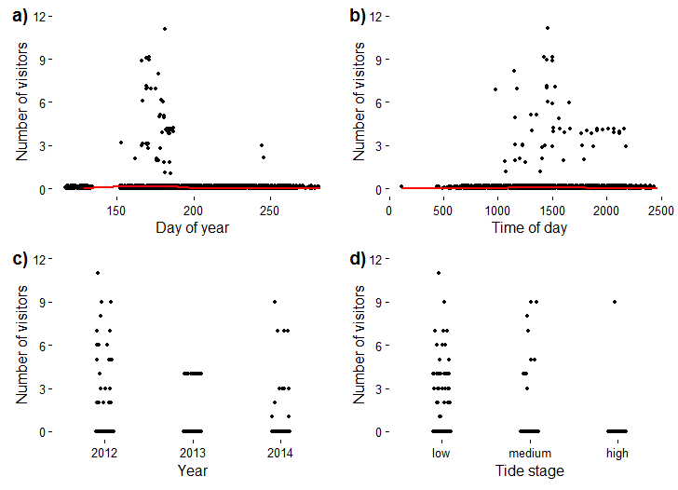

**Figure 6.** Number of visitors observed in each photo from a time-lapse photography study at Swikshak Lagoon (2012-2014) in relation to variables **a)** day of year, **b)** time of day, **c)** year, and **d)** tide stage across all years of data collection. Continuous variables (day of year, time of day) have LOESS line of fit (red line). Time of day was corrected to represent 100 units per hour, and to include after midnight light periods as part of previous day.

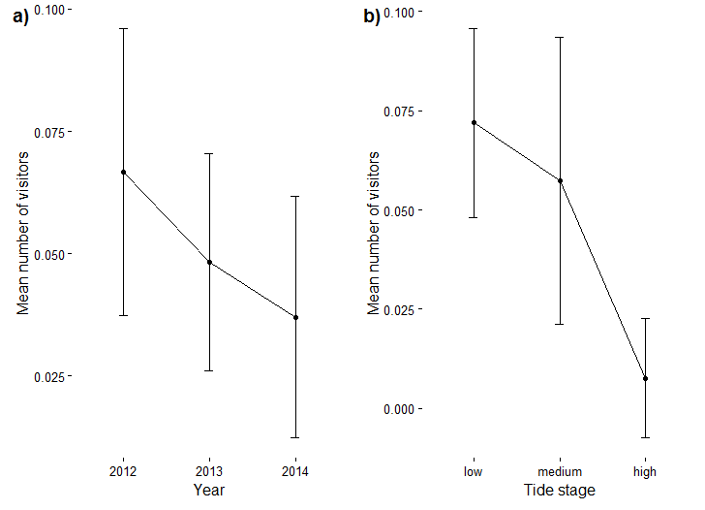

**Figure 7.** Mean number of visitors observed in photos from a time-lapse photography study at Swikshak Lagoon (2012-2014) in relation to variables **a)** year and **b)** tide stage. Error bars represent a 95% confidence interval.

Bear patterns and visitation effects

Bear presence on both sides of Swikshak Lagoon (side with visitors and without) was most strongly associated with day of year, followed by time of day, and year (Table 3 & 4). Tide stage did not have a significant association with bear presence on the side with visitation; however, it did on the side with no visitation. Mean bear residual values incorporating all variables from the ANCOVA model were compared in the presence and absence of visitors. There was a higher mean bear residual when visitors were present 1.53 (-1.94 − 8.51, n = 57) compared to when visitors were absent -0.02 (-3.40 − 9.76, n = 4647). The difference in bear numbers in the presence and absence of people was significant [one-way ANOVA; *F*(1, 4702) = 104.6, *P* <.0001]. Mean bear residuals were also compared during the primary visitation season across all three years (day 163 through 185 or June 12th-July 4th). This visitor season excluded two visitation days (day 154 and day 245) because they occurred on a day more than 8 days outside the primary visitation season with no visitation occurring on days in between. There was a higher mean bear residual during the primary visitation season when visitors were present 0.84 (-2.59 − 7.00, n = 54) compared to when visitors were absent -0.04 (-5.75 − 8.15, n = 1022). The difference in bear numbers in the presence and absence of people during the primary visitation season was significant [one-way ANOVA; *F*(1, 1074) = 11.22, *P* =.0008].

**Table 3.** ANCOVA model at south side of Swikshak Lagoon (bears and visitors present) to compare bear presence and association of variables of day of year (3rd order transformation), time of day (2nd order transformation), year, and tide stage.

|  |  |  |  |  |
| --- | --- | --- | --- | --- |
| Variable | Df | Sum Sq | F value | *P* |
| Day of year^3 | 1 | 2746 | 880.1 | < 0.0001 |
| Day of year | 1 | 975 | 312.4 | < 0.0001 |
| Time of day^2 | 1 | 114 | 36.5 | < 0.0001 |
| Time of day | 1 | 592 | 189.8 | < 0.0001 |
| Year | 2 | 905 | 145 | < 0.0001 |
| Tide stage | 2 | 4 | 0.7 | 0.51 |

**Table 4.** ANCOVA model at north side of Swikshak Lagoon (bears and no visitor presence) to compare bear presence and association of variables of day of year (3rd order transformation), time of day (2nd order transformation), year, and tide stage.

|  |  |  |  |  |
| --- | --- | --- | --- | --- |
| Variable | Df | Sum Sq | F value | *P* |
| Day of year^3 | 1 | 272 | 320.5 | < 0.0001 |
| Day of year | 1 | 88 | 103.7 | < 0.0001 |
| Time of day^2 | 1 | 15 | 17.3 | < 0.0001 |
| Time of day | 1 | 112 | 132.5 | < 0.0001 |
| Year | 2 | 57 | 33.5 | < 0.0001 |
| Tide stage | 2 | 13 | 7.5 | < 0.0006 |

Spatial distribution of bears and visitors

Bears occupied both the north and south sides of Swikshak Lagoon. Visitor presence was limited to the south side of the lagoon because the lagoon acted as a barrier to access the north side. We examined spatial distribution in the south meadow where both bears and visitors were present. Bear and visitor presence occurred across most of the meadow with areas of fairly heavy overlap (Fig. 8). The area of highest visitor concentration lay just outside the area of highest bear concentration. The outermost visitor density contour line was used to create a visitor zone (area of all visitation) and a high concentration visitor zone was created from contour lines at a density level of 0.00004 (Fig. 8). Bear frequency in and out of the visitor zone did not differ with the presence or absence of visitors (χ2 1 =0.62, *P* = 0.43). Bear frequency in and out of the high concentration visitor zone did not differ with the presence or absence of visitors (χ2 1 =1.06, *P* = 0.30).

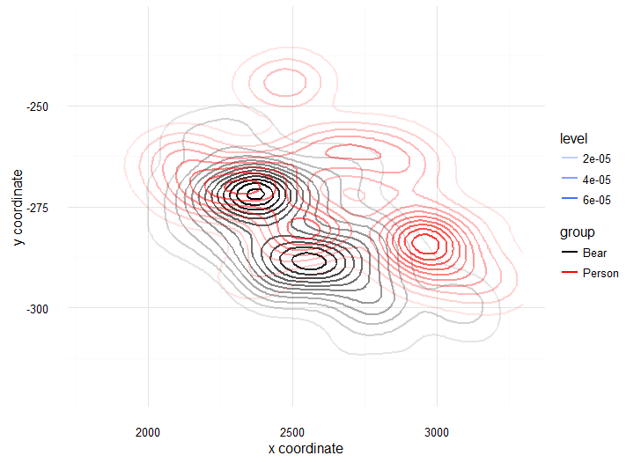

**Figure 8.** Bear and person (visitor) spatial distribution at Swikshak lagoon when visitors were present in (south side of lagoon). Contour lines represent density of bears and people that were digitized as points.

Discussion

At Katmai Bay, bear presence was affected by factors of year, day of year, time of day, and tide. Year had the largest effect on bear presence. Average bear numbers varied between years with slightly higher numbers in June and July, in the late afternoon, and at low and medium tides. Bear numbers increased in the early season and then gradually decreased as the season progressed. Bear numbers gradually increased with time of day. Bear presence at both sides of Swikshak Lagoon was affected by factors of year, day of year, and time of day. Day of year had the largest effect on bear presence at both sides of Swikshak Lagoon. Bear numbers at Swikshak Lagoon were highest during a similar season to Katmai Bay (late June to mid-July); however, more pronounced peaks and drop-offs in bear numbers were seen as the seasons progressed. Tide influenced bear presence on the north side (no visitors), but had little effect on the south side (with visitors). Bear numbers at both Katmai Bay and Swikshak Lagoon varied between years, were highest at low to medium tides, and gradually increased as the day progressed.

Variation in bear numbers between sites, years, and seasons may depend in part on food resource availability. Bears at Swikshak Lagoon and Katmai Bay may optimize sedge foraging opportunities in the early season (late June to July) and then move to other sites with food resources such as salmon or berries (Smith and Partridge 2004). Bear activity may be higher during low and medium tides in order to access tidally influenced sedge meadows. Bear use patterns between sites with no visitation (Katmai Bay and north side of Swikshak Lagoon) and some visitation (south side of Swikshak Lagoon) were similar. This suggests that the level of visitation at Swikshak Lagoon has little impact on bear presence.

Visitation patterns at Swikshak were similar to bear use patterns. Average visitation at Swikshak occurred at the end of June, in the late afternoon, at low to medium tides, which coincides with high bear activity. Bear numbers were higher when visitors were present across the entire season and during the primary visitation season (when most of the visitation occurred) compared to when visitors were absent. This is likely because visitation is targeted at times when bears are present for viewing and bears do not appear to avoid areas with human presence. Average visitor numbers did not differ between years. Visitation was highest at low to medium tides, which allows for better access to the beach and lagoon.

Bear patterns at Swikshak Lagoon and Katmai Bay (observed from 2010-2014) showed similarities and differences from the previous time-lapse study site at Geographic Harbor (observed 2007-2009). Like at Swikshak Lagoon and Katmai Bay, bear numbers at Geographic Harbor varied between years and were highest on average at low to medium tide; however, the season (day of year) and time of activity differed (Fig. 9). All three sites had food resources that are most accessible to bears during low to medium tides. Bears were not seen in high numbers in the early season at Geographic Harbor. Rather, bear numbers were highest in mid to late August across all years, which coincided with salmon runs (Turner 2012). Unlike Katmai Bay and Swikshak Lagoon, bear presence at Geographic Harbor did not gradually increase as the day progressed. Instead, bear activity peaked in the morning and evening (Turner 2012).

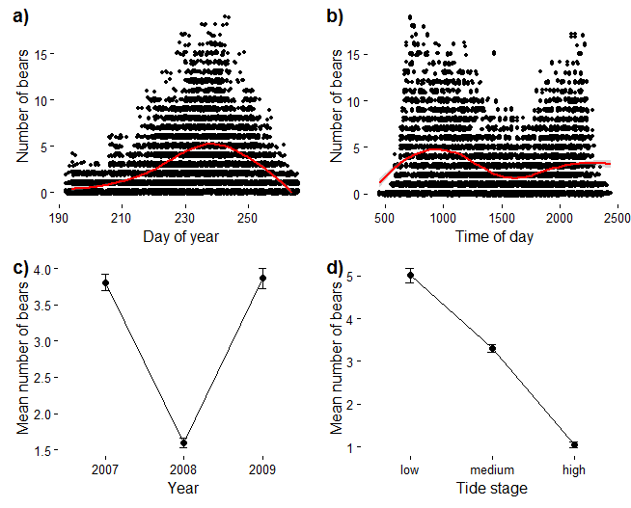

**Figure 9.** Number of bears observed in each photo from a time-lapse photography study at Geographic Harbor (2007-2009) in relation to variables a) day of year and b) time of day across all years. Mean number of bears observed in photos in relation to variables c) year and d) tide stage across all years. Continuous variables (day of year, time of day) have LOESS line of fit (red line). Time of day was corrected to represent 100 units per hour, and to include after midnight light periods as part of previous day. Error bars represent a 95% confidence interval. Original data analysis (Turner 2012).

Daily bear activity patterns are influenced by multiple factors. Bimodal selection patterns have been previously observed in brown bears (Moe et al. 2007). Bear day time selection patterns have also been associated with ambient temperature (Pigeon et al. 2016) and human avoidance (Gibeau et al. 2002, Ordiz et al. 2011). Since all three sites experience a similar coastal climate and mid-day avoidance by bears was not seen at Katmai Bay or Swikshak Lagoon, temperature is likely a minimal factor in selection patterns observed at these two sites. Differences in bear activity and spatial distribution during the day may be due in part to the level of visitation. Geographic Harbor experienced high levels of visitation during the middle of the day when bear numbers were lowest (Turner 2012). Differences in bear activity between sedge meadow foraging sites (Katmai Bay and Swikshak Lagoon) and salmon fishing (Geographic) may be tied to resource-specific foraging strategies. Differences in salmon and sedge meadow nutritional qualities such as nutrient quality and intake, digestibility, or other factors may influence bear presence on the landscape. Similarities in bear activity patterns at Katmai Bay and Swikshak Lagoon may reflect the ecological similarities of these sites.

At Swikshak Lagoon, visitor numbers were highest when bear numbers were highest. Bear spatial distribution at Swikshak Lagoon did not change with the presence or absence of people in visitation areas. In contrast, visitor presence at Geographic Harbor appeared to affect bear spatial distribution, where bears used fewer locations when visitors were present (Turner 2012). Bear patterns between the south and north sides of Swikshak Lagoon and Katmai Bay were similar, suggesting that low levels of visitation may not alter bear patterns. These findings suggest that the level of visitation may play an important role in determining to what degree bears change their activity and distribution on the landscape.

Geographic Harbor had high levels of visitation in terms of both visitor numbers and density. Geographic Harbor had considerably higher numbers of visitors (23% of photos with visitor presence, Turner 2012) compared to Swikshak Lagoon (1.2% of photos with visitor presence). The percentages of photos with visitors may not be entirely comparable between sites because photos were taken at different intervals between seasons and length and time of seasons varied. Geographic Harbor had multiple visitor groups per photo with an average of 7 visitors per group and a maximum of 29 visitors recorded in one photo. Swikshak Lagoon did not have multiple groups per photo with an average of 4.5 visitors per group and a maximum of 11 visitors in one photo. Visitor and bear numbers at Swikshak Lagoon may be underestimated due to a limited photo frame extent that may not have captured all bears and people present. Visitor presence, density, and distribution may all determine the level of impact human visitation has on bear activity.

Conclusions

With increasing levels of bear viewing at Katmai, it is essential to gain an understanding of baseline bear activity patterns and the impact of human visitation on bear patterns and distribution. Bear activity at Katmai coastal sites was influenced by spatio-temporal variables of year, day of year, time of day, and to a varying degree, tide. Our coastal time-lapse study results suggest that visitation level may be important in determining how visitors impact bears. Bear activity at coastal sites with no visitation (Katmai Bay and north Swikshak Lagoon) and some visitation (south Swikshak Lagoon) did not differ, suggesting that low levels of visitation do not significantly alter bear presence or spatial distribution. Visitation levels between Swikshak and Geographic Harbor varied greatly. The previous study at Geographic Harbor, a coastal location with high levels of concentrated visitor activity, suggested that visitor presence may alter bear activity and distribution. Although temperature or other unmeasured factors that may vary between years cannot be ruled out, the lack of a bimodal pattern in daily bear activity at both Swikshak Lagoon and Katmai Bay suggests that the pattern observed at Geographic Harbor may be related to site-specific factors. More study is needed to determine whether the bimodal pattern results from high visitor activity. Our results suggest that if high levels of visitation alter bear activity and displace bears, this effect is limited to areas where visitation is relatively more concentrated on the landscape. Potential effects of high visitation could have consequences for bear fitness, because changes in bear activity and displacement can negatively affect a bear’s ability to access important foraging sites (Smith and Partridge 2004).

At Katmai, bear viewing is a popular activity for visitors to learn about and observe bears. It is promising that visitor presence alone does not appear to negatively impact coastal brown bears. Though some bears are habituated to varying levels of human use, it is important to minimize the impacts of visitation. The results of this study can help us determine which bear-viewing areas would benefit from further study within Katmai by looking at visitor activity levels and comparing them to visitation levels at Swikshak and Geographic Harbor. Management strategies for sites with low levels of visitation and similar ecological characteristics to Swikshak may include monitoring visitor numbers each season. Bear viewing areas with multiple visitor groups per day and high visitor numbers should be targeted as management priorities if displacement is observed there. As suggested by the previous time-lapse photography study (Turner 2012), these heavily visited sites may benefit from increased ranger presence or designated viewing areas. At sites with high levels of visitation, ranger presence may help ensure that BBVP guidelines are being followed. More study is needed to understand the visitation level at which bears are displaced and activity patterns are altered. More research is needed to determine how human presence may affect bear family group and sex distribution. Continued research on site-specific foraging strategies and how they shape bear activity would increase our understanding of natural coastal bear activity patterns. Additional time-lapse photography studies at coastal and interior sites could help us determine whether variations in bear activity patterns are a result of human presence or other natural factors that we have not considered. A Katmai backcountry management plan with site-specific guidelines based on site characteristics and visitor levels is suggested in order to balance visitor bear viewing opportunities while minimizing disturbances to bears and their habitats.

Literature Cited

Fortin, J. K., K. D. Rode, G. H. Hilderbrand, J. Wilder, S. Farley, C. Jorgenson, and B. G. Marcot. 2016. Impacts of human recreation on brown bears (*Ursus arctos*): a review and new management tool. PLoS ONE 11(1).

Gibeau, M. L., A. P. Clevenger, S. Herrero, and J. Wierzchowski. 2002. Grizzly bear response to human development and activities in the Bow River Watershed, Alberta, Canada. Biological Conservation 103: 227-236.

Hamon, T. R., H. S. Kim, T. L. Olson, and T. Harrington. 2007. Determining bear activity levels in the lower Brooks River, an area of high visitor use in Katmai National Park, Alaska. National Park Service, King Salmon, Alaska.

Miller, S. D., G. C. White, R. A. Sellers, H. V. Reynolds, J. W. Schoen, K. Titus, V. G. Barnes, R. B. Smith, R. R. Nelson, W. B. Ballard, and C. C. Schwartz. 1997. Brown and black bear density estimation in Alaska using radiotelemetry and replicated mark-resight techniques. Wildlife Monographs 133.

Moe, T. F., J. Kindberg, I. Jansson, and J. E. Swenson. 2007. Importance of diel behavior when studying habitat selection: examples from female Scandinavian brown bears (*Ursus arctos*). Canadian Journal of Zoology. 85: 518-525.

National Park Service & Alaska Department of Fish and Game. 2003. Best Practices for viewing bears on the west side of Cook Inlet and the Katmai Coast. National Park Service, King Salmon, Alaska.

Nicolato, K. and C. Turner. 2014. Time-lapse photography data protocols. National Park Service, King Salmon, Alaska.

Ordiz, A., O. G. Stoen, M. Delibes, and J. E. Swenson. 2011. Predators or prey? Spatio-temporal discrimination of human-derived risk by brown bears. Oecologia 166(1): 59-67.

Pigeon, K. E., E. Cardinal, G. B. Stenhouse, and S. D. Cote. 2016. Staying cool in a changing landscape: the influence of maximum daily ambient temperature on grizzly bear habitat selection. Oecologia 181: 1101-1116.

Sellers, R., S. Miller, T. Smith, and R. Potts. 1999. Population dynamics of a naturally regulated brown bear population on the coast of Katmai National Park and Preserve. National Park Service and Alaska Department of Fish and Game. Anchorage, Alaska.

Smith, T. S. and S. T. Partridge. 2004. Dynamics of intertidal foraging by coastal brown bears in Southwestern Alaska. Journal of Wildlife Management 68(2): 233-240.

Strawn, M. and Y. Le. 2014. Katmai National Park and Preserve visitor study. Washington State University, Pullman, Washington.

Turner, C. N. 2012. Determining the effectiveness of park management strategies at a coastal brown bear viewing site in Katmai National Park, Alaska. M. Sc. Thesis, Royal Roads University, British Columbia, Canada.

Appendix A:

Best Practices for Viewing Bears on the 

West Side of Cook Inlet and the Katmai Coast

**Background**

Public interest in watching brown bears has increased dramatically in Alaska during the past decade. Some of this activity is incidental to other pursuits such as sport fishing, hiking, or flight seeing, but much of it is specifically targeted at bear viewing. Whenever bears and people interact with each other there are potential benefits and dangers for both species. Natural resource managers in the Alaska Department of Fish and Game and the National Park Service, with input from bear viewing guides and the general public, have developed the following “best viewing practices” in an effort to minimize adverse impacts on bears and their habitat while maximizing the opportunity for people to learn about and enjoy bears.

The best way to watch bears is to avoid any close encounters that would influence the bears’ behavior or activities. There are currently many opportunities to watch bears in this way, but in areas where bears are seasonally concentrated near abundant food sources, nearby viewing may be possible. In most cases, the closer bears and people are to each other, the greater the chance for interaction and the greater the need for developing ways of encouraging consistent appropriate human conduct around bears and their habitat.

Even though brown bears are inherently wild and potentially dangerous, they have developed distinct social cues and practices that allow them to live and eat near other bears. This is especially true around seasonally abundant food sources like sedge meadows and salmon spawning streams. If people learn and adhere to the rules the bears observe for themselves, they will be more likely to accept our presence as an unobtrusive part of the environment, and will continue to feed and carry on their natural behavior while being watched. A better understanding of bear behavior will also reduce dangerous encounters and thereby benefit bears and people alike.

The following “best practices” were produced principally for the west side of Cook Inlet and the Katmai Coast, Alaska, an area that stretches from the Susitna River to Cape Kubugakli, but they may be applicable to other areas as well. They provide natural resource managers, bear viewing guides, and the general public with a template for dealing with bear-people interactions. In some areas site-specific guidelines or regulations may be necessary to address unique circumstances, and close cooperation between agencies and the public will be needed to develop those.

**Goal**

Minimize disturbance to bears and their habitat while providing opportunities to enjoy, observe and photograph bears in the wild while learning about their natural history, behavior and habitat requirements.

3/27/2003 Best Practices for Viewing Bears, Alaska Department of Fish and Game and National Park Service

**Best Practices**

**1) Reduce disturbance of bears and their habitat.**

a) **Respect bears “personal space”.** People should never closely approach, crowd, pursue, disturb or displace bears. Bears have limited opportunities to gain calories necessary to maintain life and prepare for denning. Displacing bears from feeding sites has serious consequences for them.

The distance at which bears can allow people varies dramatically in different situations and between individual bears. Human behavior also has a large impact on a bear’s “personal space”. Bears use body language and vocalizations to communicate with each other. The better humans understand these signals, the more conflicts can be avoided. Spatial and temporal restrictions on human activity may be necessary to ensure that the less tolerant bears have access to the feeding sites.

b) **Promote predictable human behavior.** Each encounter is a learning experience for both bears and people. Appropriate and consistent human responses to bears minimize the chances of dangerous surprise encounters. Consistent appropriate human behavior can provide safer and better bear viewing experiences.

1. While watching bears from a long distance it may be advantageous to remain inconspicuous, but in most cases it is best to stay in the open where bears can see people and choose to avoid them if they wish. Hiding from bears increases the likelihood that people will have a surprise encounter that could result in a dangerous situation for the bear and/or the person. Minimizing noise and movement while viewing bears will help limit disturbance to bears using the area.

c) **Encourage people to stay together in bear country.** Groups of people (three or more) are generally safer than individuals, but too large a group also has a greater probability of disturbing or displacing bears. The surrounding geography and vegetation, typical bear behavior and the actions of the people will determine the optimal group size. In many cases, the behavior of the group may be more disruptive to bears than the group size. Members of a single viewing group should stay within a few arms’ lengths of one another. Bears are apt to perceive a greater threat from two or more nearby groups than a single cohesive group.

d) **Consistently use the same viewing sites.** In places where people regularly visit (e.g., every day or so), consistent use of the same site makes human use more predictable for bears, and thus may help minimize disturbance. People should avoid using areas that monopolize a site where the bears prefer to fish or feed.

e) **Access viewing sites in a consistent manner that minimizes disturbances.** When going to and from viewing sites, people should strive to minimize disturbance to bears, bear habitat and other people. Access to viewing areas by aircraft, vehicle or boat should be done in ways that are respectful to both bears

3/27/2003 2 Best Practices for Viewing Bears, Alaska Department of Fish and Game and National Park Service

and people. When going to a viewing area on foot, it is usually best to be visible and casual while approaching rather than sneaking to the area and possibly surprising bears. Brushy surroundings that are used as resting and secure areas by bears should be avoided. Use of an established trail may make human movements more predictable to bears that frequent an area.

f) **Flight-seeing and other vehicle-based bear viewing should be conducted in a manner that is minimizes disturbance.** Guidelines for reducing bear disturbance while engaged in viewing bears from planes, motorized watercraft, kayaks or land-based vehicles are equivalent to other bear viewing practices. Consistency and minimal displacement and disturbance of bears are the key factors to be considered. Site-specific recommendations and regulations may be necessary in areas where problems arise.

g) **Some recreational activities next to critical feeding areas and/or travel routes may contribute to food-conditioning and displacement of bears.** Human activities such as overnight camping and fishing may attract and/or displace some bears near important feeding areas, and should carefully monitored and managed. Bears, especially young ones, are curious and exploitive of new situations. Campsites provide opportunities for young bears to get into trouble and should be located well away from bear travel corridors and feeding sites. Sport anglers must be careful to avoid attracting bears by playing fish they have caught and/or storing fish in an unsecured manner.

h) **Optimal numbers of people should be evaluated at well-known bear viewing sites.** This may be necessary to maintain high quality bear viewing experiences and to minimize disturbance. Optimal numbers of people should be determined by observing bear behavior and access to the area. If optimal numbers of people need to be established at viewing sites, they will be based on impacts to bears, visitor experience, and general habitat protection, and will be developed with public participation.

**2) Make viewers unobtrusive components of the bears’ environment.**

a) **Ensure that bears do not obtain any food from people.** Bear-resistant food and garbage storage, as well as efforts to ensure bears do not obtain fish or game from humans are critical. No food or other object should be abandoned in order to distract an approaching bear. Do not cook near bear travel corridors or feeding sites and ensure that all people leave no trace of food or garbage during or after their visit.

b) **Curious or aggressive bears should be actively discouraged from approaching people.** If a bear is approaching people, they need to make sure they are not inadvertently blocking its travel path or monopolizing a feeding site. If, after people attempt to get out of its way, a bear continues to approach too closely, then they should assert themselves to define and defend a consistent personal space. Assertive actions should begin with the most innocuous such as holding one’s ground (not moving away from the bear), raising one’s arms and

3/27/2003 3 Best Practices for Viewing Bears, Alaska Department of Fish and Game and National Park Service 3/27/2003 4

waving, speaking to the bear, and standing on a higher object. If approach continues, assertive actions should escalate appropriately. If a young bear learns it can push people around, this behavior is reinforced and the bear can become a problem.

c) **Trained bear viewing guides can reduce impacts of viewing and improve viewers’ experiences.** Well-trained and experienced guides or government staff can ensure people follow guidelines and behave in an appropriate and consistent manner. Guides also provide agencies with information on human activities in the field and can be an excellent conduit for agencies to get information to and from the public.

a) **Concise, accurate bear education information should be provided at key locations.** Lodges, air-taxi offices, agency offices, visitor centers, web sites, and charter boats are excellent outlets for providing people with education materials.

b) **Guide training should be available for anyone taking people into the field for bear viewing.** Training programs that offer information about basic bear behavior, habitat considerations, and human impacts on bears will greatly enhance visitor experiences and encourage better stewardship of resources. In some areas, mandatory training may be considered for commercial operators and agency personnel dealing with bear viewers.

c) **Human impacts on bears and their habitat should be monitored.** Natural resource managers have an obligation to learn as much as possible about how people are affecting bears and to take action when warranted. Monitoring may entail simply keeping in touch with guides and other people or it may be appropriate to develop and implement a detailed scientific protocol. Information collection should be ongoing and open to public interaction.

**3) Incorporate education in to every bear viewing opportunity.**

a) **Concise, accurate bear education information should be provided at key locations.** Lodges, air-taxi offices, agency offices, visitor centers, web sites, and charter boats are excellent outlets for providing people with education materials.

b) **Guide training should be available for anyone taking people into the field for bear viewing.** Training programs that offer information about basic bear behavior, habitat considerations, and human impacts on bears will greatly enhance visitor experiences and encourage better stewardship of resources. In some areas, mandatory training may be considered for commercial operators and agency personnel dealing with bear viewers.

c) **Human impacts on bears and their habitat should be monitored.** Natural resource managers have an obligation to learn as much as possible about how people are affecting bears and to take action when warranted. Monitoring may entail simply keeping in touch with guides and other people or it may be appropriate to develop and implement a detailed scientific protocol. Information collection should be ongoing and open to public interaction.

The Department of the Interior protects and manages the nation’s natural resources and cultural heritage; provides scientific and other information about those resources; and honors its special responsibilities to American Indians, Alaska Natives, and affiliated Island Communities.

NPS XXXXXX, Month Year (The Fort Collins Support Office will fill out this line for you)

|  |  |
| --- | --- |
|  | |
| National Park Service  U.S. Department of the Interior | National Park Service Logo |

**Natural Resource Stewardship and Science**

1201 Oakridge Drive, Suite 150  
Fort Collins, CO 80525

[www.nature.nps.gov](http://www.nature.nps.gov/)

EXPERIENCE YOUR AMERICA TM